Driving in the UK - court reports

Read the following reports about two people who went to court because they did not have the documents they needed to drive in the UK. This means that they committed a driving offence.

Which document did neither person have?

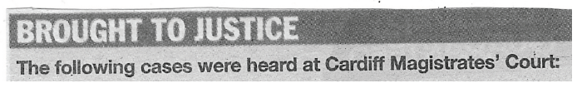

PERSON A PERSON B

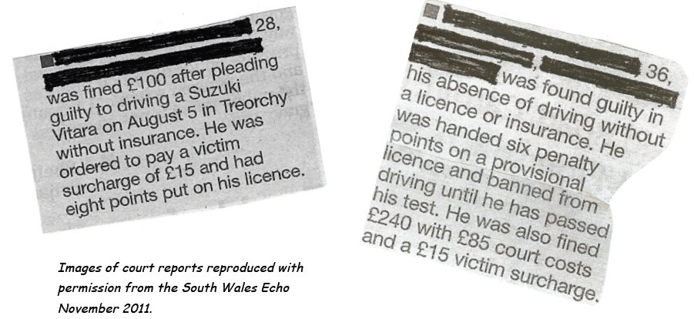

To drive in the UK you must have a valid driving licence, car insurance, vehicle tax and an MOT certificate. If you don’t have these documents you can be stopped by the police and you may have to go to court.

Activity One

Find these words in the news reports and match the words to their meaning:

- guilty | - made to pay some money when you have done something that is against the law
- fined | - not allowed to do something like driving because you have committed a crime
- handed | - given; for example "he was given 6 points on his licence"
- a victim surcharge | - having done something wrong or against the law
- penalty points | - to tell the magistrate that you committed the offence
- court costs | - to decide that someone is guilty of committing an offence
- banned | - points that are printed on your driving licence to show that you have committed a driving offence - if you get 12 points you will lose your licence and you won’t be able to drive
- to plead guilty | - money you pay that goes into a fund to help people who are victims of crime
- to find someone guilty | - money you have to pay to the court to cover the costs of your case

ANSWERS:
- ___
- ___
- ___
- ___
- ___
- ___
- ___
- ___

Activity Two

Answer these questions about the court reports:

1. Which person admitted they had committed the offence - A or B? _______
2. Which person was found guilty - A or B? ________
3. What punishment did person A receive? (tick the correct answer)
  - A fine of £15 victim surcharge of £100 and 8 penalty points
  - A fine of £100, victim surcharge of £15 and 6 penalty points
  - A fine of £100, victim surcharge of £15 and 8 penalty points
4. What punishment did person B receive?
  - A fine of £240, court costs of £85, 6 penalty points and banned from driving
  - A fine of £85, court costs of £15, 8 penalty points and banned from driving
  - A fine of £100, court costs of £85, 6 penalty points and banned from driving

Activity Three

In newspaper articles like these we often use the passive. Example:
A man stole the car. (active)
The car was stolen. (passive)

Read these sentences. Are they passive (P) or active (A)?
1. The magistrate fined person A £100. ______
2. Person A was fined £100. ______
3. Person B was found guilty of driving without insurance. ______
4. The court found Person B guilty of driving without insurance. ______
5. Person A received eight points on their licence. ______
6. Person B was given six points on a provisional licence.
7. Person B was banned from driving until he has passed his test. ______
8. The court ordered Person A to pay a victim surcharge. ______

©British Council 2012

